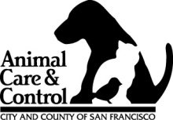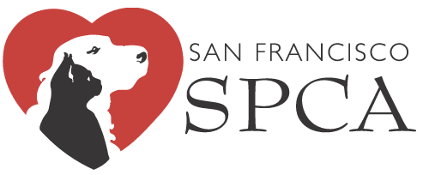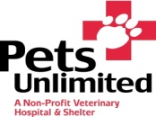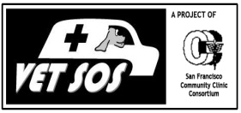
San Francisco Disaster Preparedness Coalition for Animals
SFDPCA

Become a Volunteer Animal Disaster Service Worker!

Step 1: Attend NERT Training

Taking NERT is a required step to become an Animal Disaster Service Worker. You may take NERT on your own or through this special NERT training. This training has been arranged especially for people concerned with animal welfare after a disaster. You must attend both sessions.

When: Saturday Sept. 25th (8:30am-5:30pm) and Saturday Oct 9th (8:30am-5:30pm)
Where: The Hamm’s Building, 1550 Bryant Street.
Cost: Free!

To register, please go to www.sf-fire.org and click on the link for “Neighborhood Emergency Response Team (NERT)” under “Related Links.” Or call the NERT Training Registration Line at 415-970-2024.

Step 2: Attend Disaster Animal Response Training*

The next required step is a 4-session training course specifically about disaster animal response training. The course is led by the SFDPCA and is designed for NERT graduates who want to be involved in helping animals after a disaster. In the event of emergency, DPCA-certified volunteers will assist with helping triage injured animals and assisting in temporary animal shelters. You must attend all 4 sessions to become certified as an Animal Disaster Service Worker.
*includes Pet First Aid certification!

When: November 13, January 15, March 12, and May 21. Each session 9:00am-1:00pm.
Where: The Hamm’s Building, 1550 Bryant.
Cost: Free!

Eligibility: NERT certification and completed FEMA ICS online courses IS-100a, IS-200a, and IS-700a required. You must bring proof of NERT certification and FEMA ICS completion by the final session of DART in order to graduate. For FEMA ICS courses, go to http://training.fema.gov/IS and click “ISP Course List.” Print out a certificate of completion after each course.

Questions? Please contact Dr. Bing Dilts (415-554-9417) at The San Francisco Department of Animal Care and Control.

Thanks for helping the animals!

