
Ring-neck Doves
Make Great Pets!

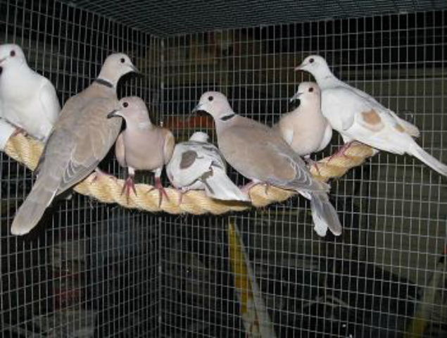
Ring-neck doves, rescued from animal shelters around the Bay Area, make wonderful, gentle pets. They’re beautiful, sweet, calm, and make a variety of expressive cooing sounds. Though most content in pairs or small flocks, single doves can become quite devoted and affectionate with their owners. These doves have been raised in captivity for thousands of years and, as domestics, are ill equipped to survive in the wild.

Doves need:
- Safe place (indoors or outdoors, protected from weather and predators. Wire on outdoor aviaries must be welded heavy-gauge with openings no more than ½” square)
- Room to move around (minimum cage size 30” x 24”—bigger is better)
- Fresh food (dove mix), water and grit at all times plus occasional greens
- Company (either yours or another dove’s)
- Family planning (if you have a mated pair, you need to replace real eggs with fake ones)
- Avian vet care should they become sick or injured. There are a number of excellent avian vets in the Bay Area

For more info, visit MickaCoo Pigeon & Dove Rescue at www.MickaCoo.org and check out Pigeon Talk at www.pigeons.biz/forums (a great web group with lots of info and resources on doves and pigeons).

To adopt a ring-neck dove, contact Elizabeth at AdoptKings@gmail.com
or Cathy at magoose@pacbell.net (408) 225-1729

