We are collecting yellow Pepsi caps!

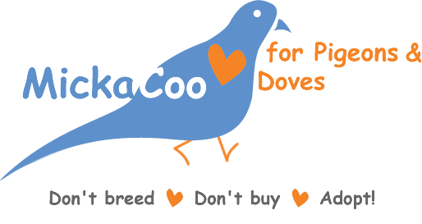
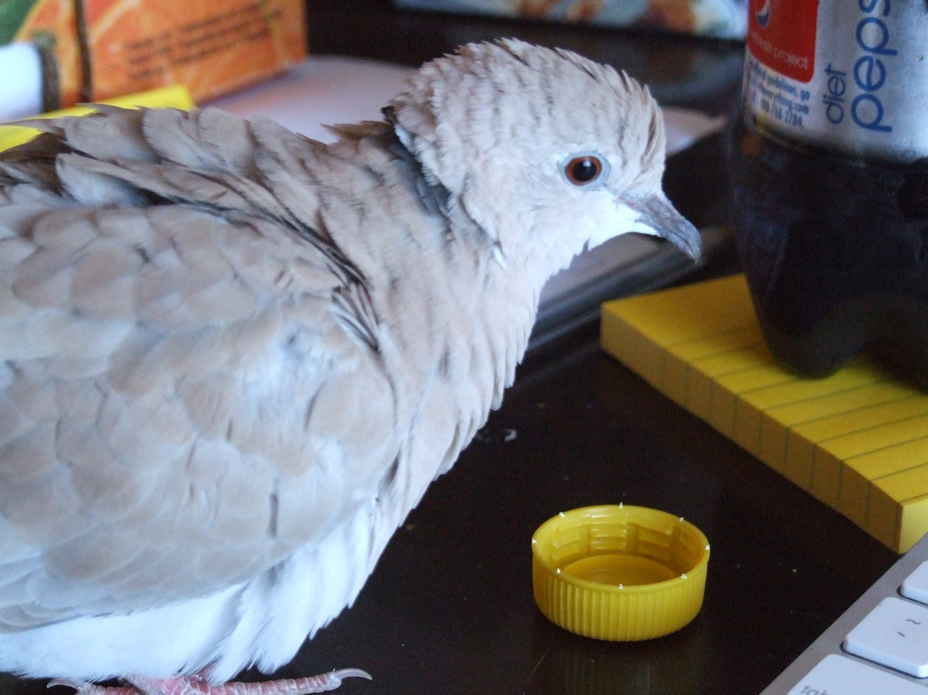
Please help MickaCoo Pigeon & Dove Rescue win a much-needed Pepsi Refresh grant!

